Software Design Document

Use Case Diagram

Andrew Vaughn, Brian Hawkins, Stephen Knofczynski

Team OnShop

**Summary**

**Contents**

1. **Use Case Diagram**
   1. **User Accesses index.html**

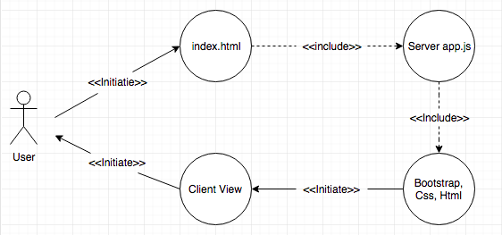

Figure 1. The 1st Diagram for Use Case index.html

* 1. **User Accesses register.html**

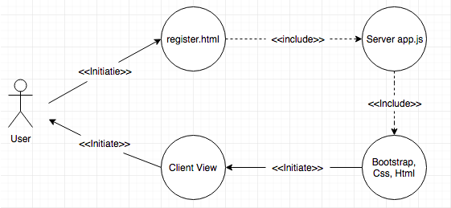

Figure 2. The 2nd Diagram for Use case register.html

* 1. **User Accesses login.html**

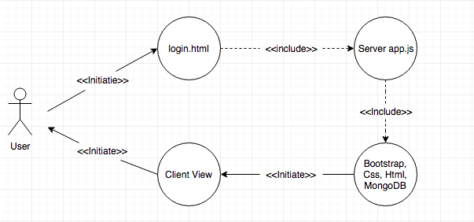

Figure 3. 3rd diagram for Use Case login.html

* 1. **User Submits Registration**

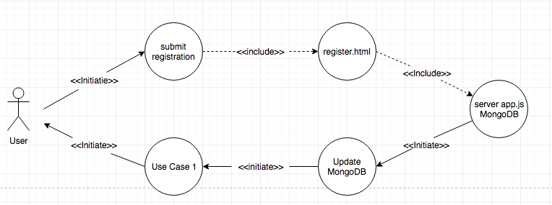

Figure 4. 4th Diagram for Use Case Registration

* 1. **User Submits Login**

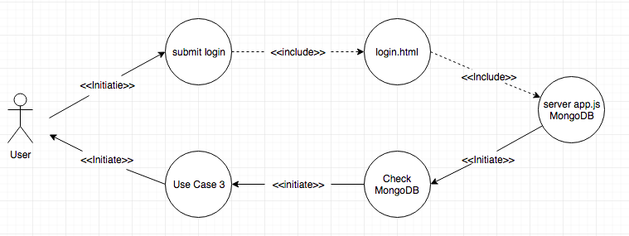

Figure 5. 5th Diagram for Use Case Login

* 1. **User Accesses profile.html**

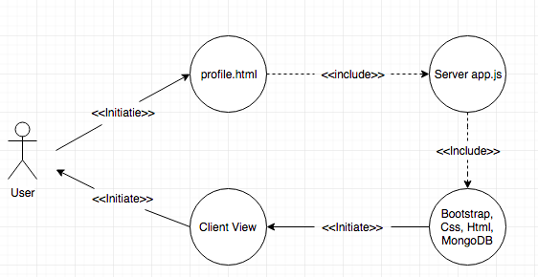

Figure 6. 6th Diagram for Use Case profile.html

* 1. **Send Data**

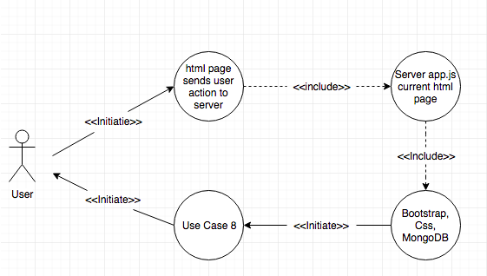

Figure 7. 7th Diagram for Use Case Send Data

* 1. **Request Data**

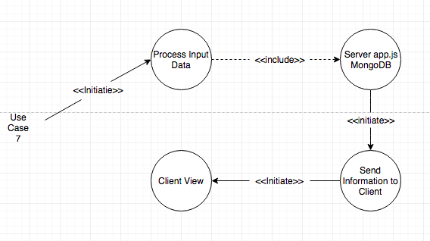

Figure 8. 8th Diagram for Use Case Request Data

* 1. **Item Added to Checkout**

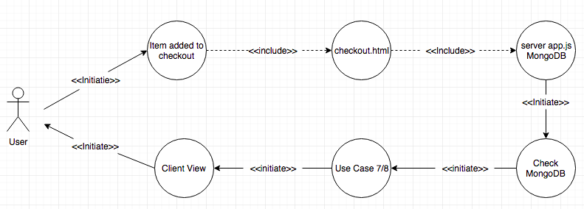

Figure 9. 9th Diagram for Use Case Add Item to Checkout

* 1. **User Updates Profile**

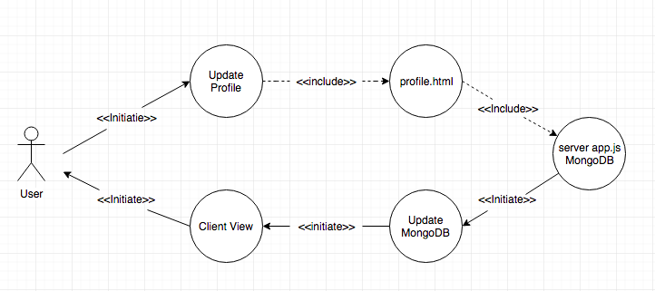

Figure 10. 10th Diagram for Use Case Update Profile

* 1. **Admin Adds Product to DB**

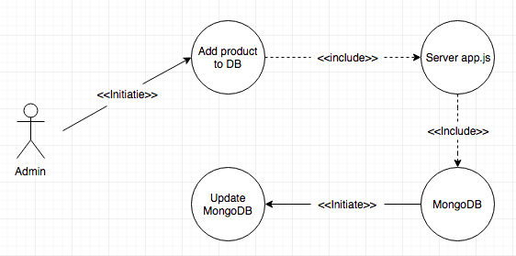

Figure 11. 11th Diagram for use Case Add Product to DB

* 1. **Admin Deletes Profile**

1. **Class Diagram**

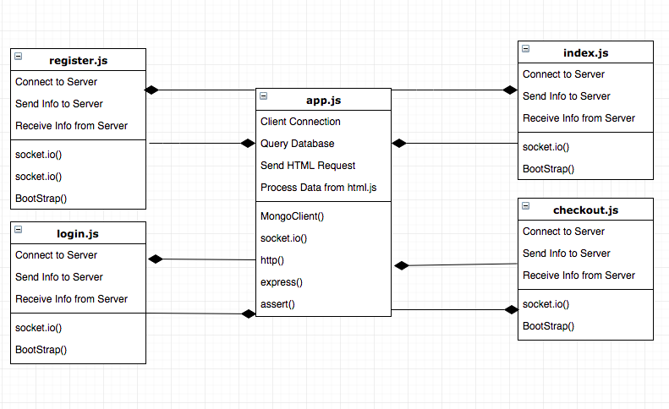

Figure 12. Class Diagram

1. **Sequence Diagram**
   1. **Sequence Diagram – Update Profile**

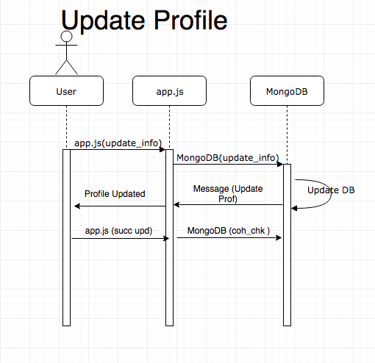

Figure 13. 1st Diagram for Sequence Diagram Update Profile

* 1. **Sequence Diagram – New Registration**

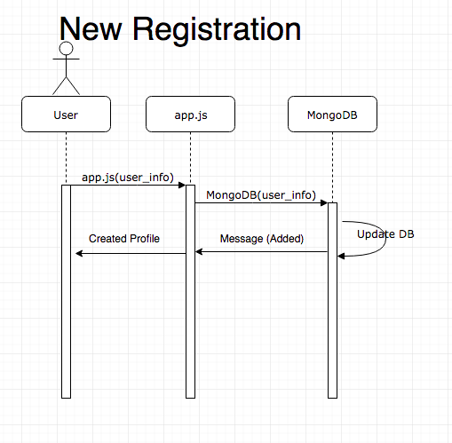

Figure 14. 2nd Diagram for Sequence Diagram New Registration

* 1. **Sequence Diagram – Item added to Checkout**

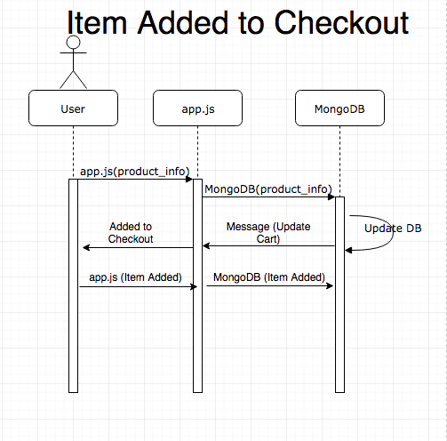

Figure 15. 3rd Diagram for Sequence Diagram Item Added to Checkout

1. **Statechart Diagram**

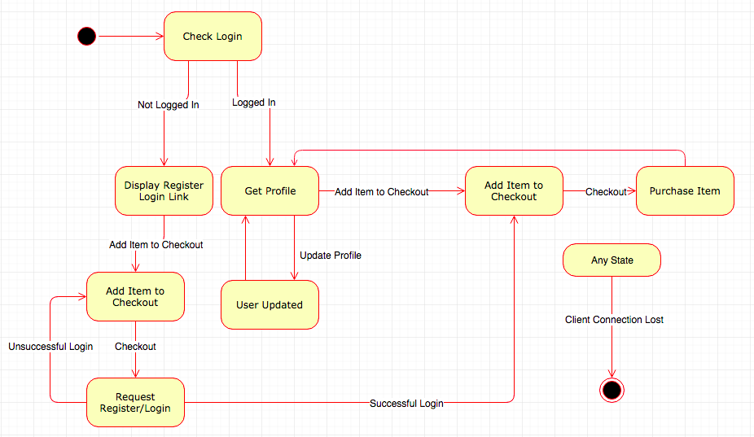

Figure 16. Statechart Diagram

1. **Activity Diagram**
   1. **Activity Diagram – Checkout**

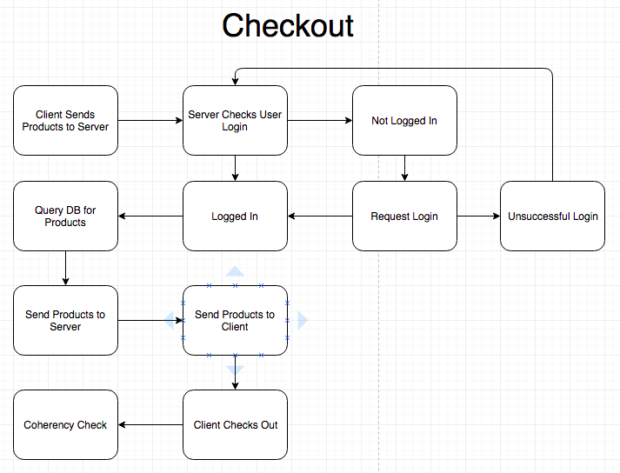

Figure 17. 1st Diagram for Activity Diagram Checkout

* 1. **Activity Diagram – New Registration**

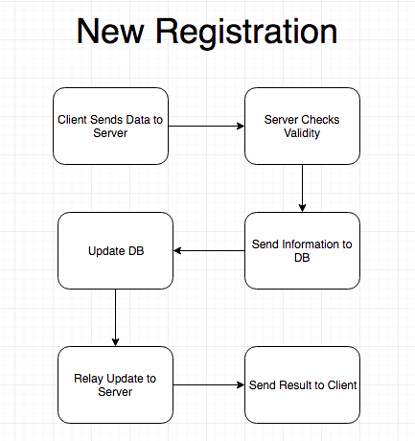

Figure 18. 2nd Diagram for Activity Diagram New Registration

* 1. **Activity Diagram – Update Profile**

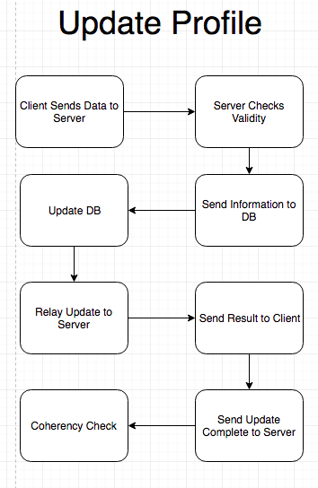

Figure 19. 3rd Diagram for Activity Diagram Update Profile

1. **Package Diagram**

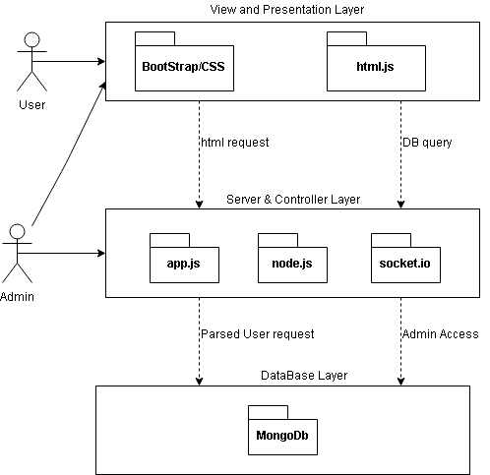

Figure 20. Package Diagram

**References**

Style and front end of website: <https://github.com/twbs/bootstrap>

Server side: <https://github.com/nodejs/node>

Client-Server communication: <https://github.com/expressjs/express>

Database: <https://github.com/mongodb/mongo>

**Appendix**

Andrew Vaughn : Diagrams/Design

Stephen Knofczynski : Diagrams/Design

Brian Hawkins : Diagrams/Design

Sam Groenjes: Diagrams/Design